**CMPG223 GROUP PROJECT**

**GROUP 19**

Lecturers: Mr Nathan Morgenrood

Mr Heinke Lubbe

Group members: P Nel – 34263306

HTN Quinn – 42263867

B Zvomuno – 31709974

O Zungu – 42132975

A Murray – 33485356

R Lombaard – 33619190

Contents

DevTracker app consist of the following forms: 2

Login Form 2

Registration Form 3

Developer from 4

Admin form 6

# Devices and software required:

DevTracker runs on Microsoft visual studio 2022 : Device specification are as follows:

If x86 or AMD64/x64, requires a **1.6 GHz or faster processor** Requires 1 GB of RAM (1.5 GB if running on a virtual machine) Requires 1 GB of available hard disk space Requires 1024 by 768 or higher display resolution

# DevTracker app consist of the following forms:

## Login Form

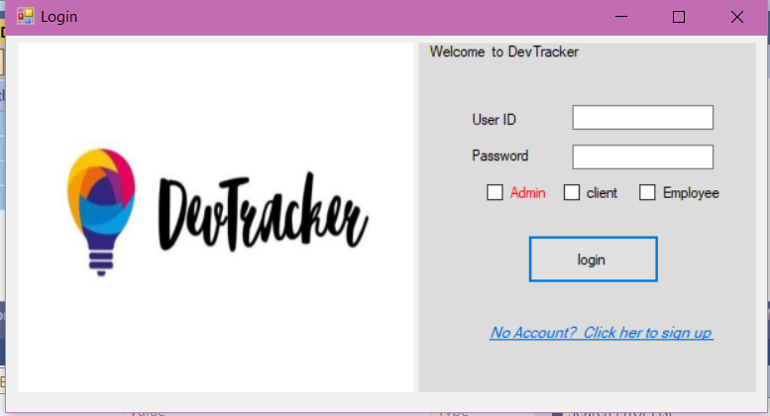

This form is used to log into the system.

User must have a user ID and password to access the system.

Steps to access the system:

1. Enter your user ID
2. Enter your password
3. Click on the correct role
4. Click login button

User also has to specify their role(admin, client or employees).

User cannot click all roles at once

If username and ID does not match the role checked on the checkboxes user will not be permitted into the system

## Registration Form

If the user does not have an account he/she must click the blue text on the login form:



From there the user will be directed to the following from:

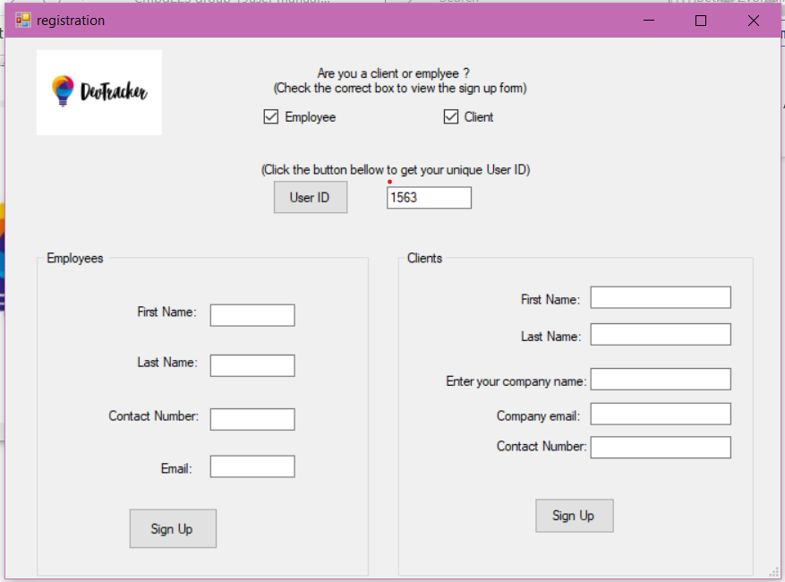

How to use registration form:

1. User must select whether they are a clints or employee
2. Click the user ID Button to generate your own personal unique userID
3. You will be presented with the clients /employee forms
4. Enter your details accordingly
5. Click sign up
6. Your details will be recorded and you will be guided back to the login form so that you may log in

## Developer from

The developer form looks as follows:

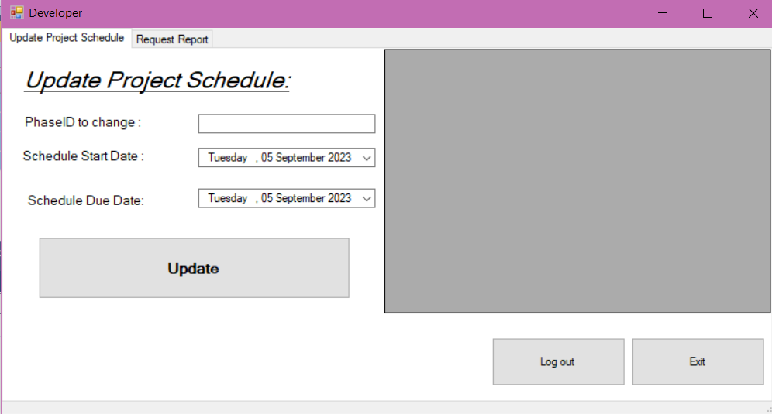

It consists of 2 tabs namely Update project schedules tab and request reports tab

Its main function is to allow the developer to update the project schedule and progress for the projects

How to use developer form for updating project schedules:

1. Click on the update project schedules tab
2. Enter the ID of the project phase you want to update(not projects, project schedules and project phases are connected via primary keys and foreign keys
3. Pick a start date and a due date
4. Click update button
5. Click login button to go back to log in form and click exit to exit the application

How to use developer form for viewing reports:

Developers/employees can only request reports on their upcoming projects

1 . Click the request button and you will be presented with all upcoming projects and their progress

## Admin form

The admin form consists of the tabs listed below:

Manage clients tab:

How to use this tab (please not that this form can only be accessed using a special admin key and password

1. To add new clients Enter details according and correctly then click add clients button
2. To update clients details Enter details according and correctly then click the update clients button
3. Enter user id of client you wish to delete and click the remove client button

Manage projects tab

How to use this tab (please not that this form can only be accessed using a special admin key and password

1. To add new projects Enter details according and correctly then click add project button
2. To update projects details Enter details according and correctly then click the update projects button
3. Enter project id of project you wish to delete and click the remove projects button

Manage project assignments tab

How to use this tab (please not that this form can only be accessed using a special admin key and password

1. To add new projects assignments Enter details according and correctly then click add button.
2. Enter Assignment id of project assignment you wish to delete and click the remove button .

